**SHINE UTENSILS**

*Developer Guide*

|  |  |  |
| --- | --- | --- |
| **Supervisor.** | **Miss Aatika** | |
| **Batch.** | **2110c1** | |
| **Group.** |  | |
| **Serial No.** | **Enrollment Number** | **Student Name** |
| 1. | 1340176 | MAHNOOR |
| 2. | 1341258 | NEHA |
| 3. | 1341255 | HASHIR AHMED |

**ACKNOWLEDGEMENT**

Before anything, I would like to thanks my beloved teacher who helped us a lot in reviewing this project within the limited time frame.

Secondly, we would also like to thank the eProject team at Aptech Head Office, who gave us the golden opportunity to do this wonderful project about **SHINE UTENILS**

Thirdly, we also thank the eProject team, some of the benefits are as under: Re-enforcement of skills happens in the experiential learning process. ∙ A mentor, ensuring that we do not get drifted, constantly guides us. ∙ It gives us a lot of confidence to face an interview as we have worked on a project. We can explain virtually everything on the subject

***SYNOPSIS***

With the help of technology, we are providing people ease to survey our online website and easily shop at home our **shine utensils product.** We are providing relaxing survey to our website. Attached all the information about the main species of the utensils. So shares the perfect relaxing images through the website for everyone to know. For the convenience of the people we have provided map for the route. Best **shine utensils** website to visit.

***PROBLEM STATEMNET***

The Shine Utensils is the famous Utensils shop which consists of varieties. It has various shops located at different location. To advertise about the quality, types and to reach remote masses the shop owner wants to create a website.

**REQUIRMENT SPECIFICATION**

The Web site is to be created based on the following requirements.

1. Home page should give some description about the utensils stores and also when it came into existence.
2. Also, different section of the type of utensils likes which quality and their respective rates must be enlisted.
3. Specification of the utensils must be added.
4. Also, the day in which the discount of how much percent is offered.
5. About Us
6. Contact Us: location of different counters.
7. Comparison page (must allowed the same product of different type to be compared.
8. Feedback: feed on the quality and services can be added.

*SCOPE OF THE WORK IN BRIEF*

The website is to be developed for the Windows Platform using **HTML5** , **CSS,** **JavaScript** , **bootstrap** and **jQuery.** The site should work well in all leading browsers including Chrome, Firefox etc.

***AGGREGRATE SITEMAP***

***SITEMAP ENGLISH***

***WEBSITE SCREENSHOTS***

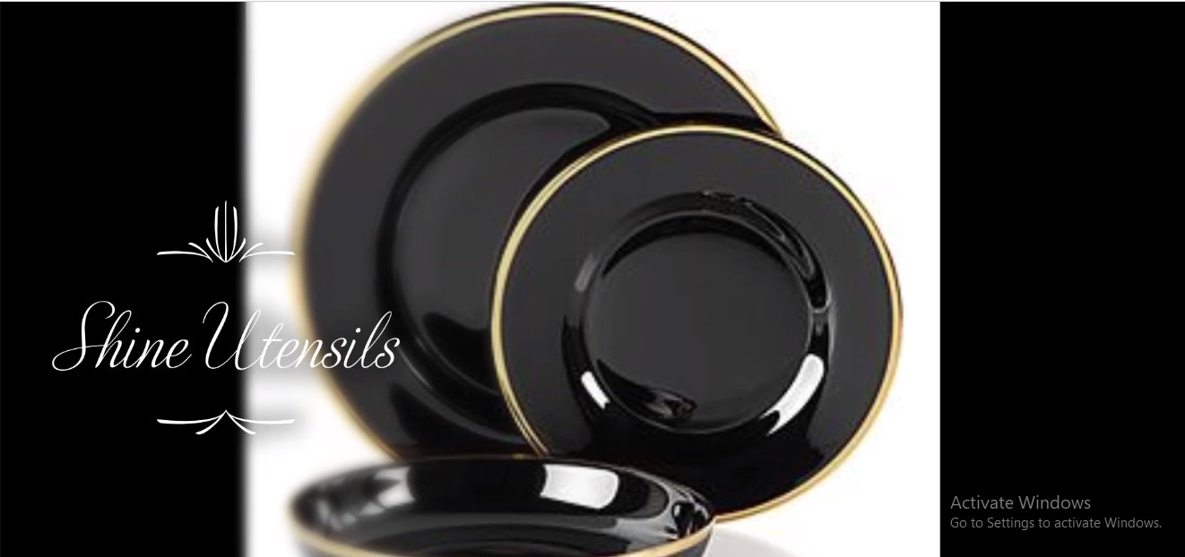

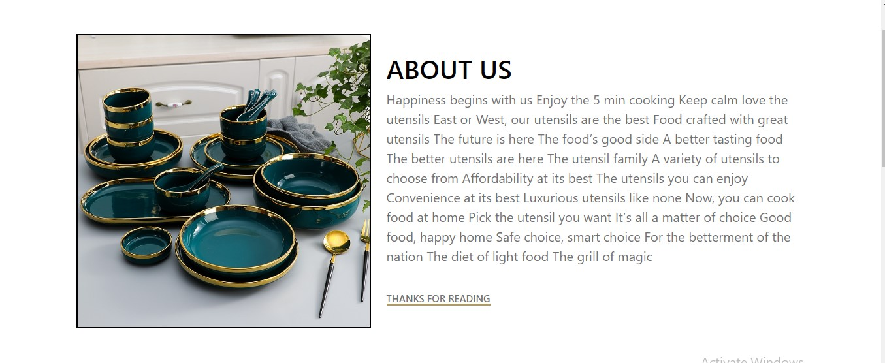

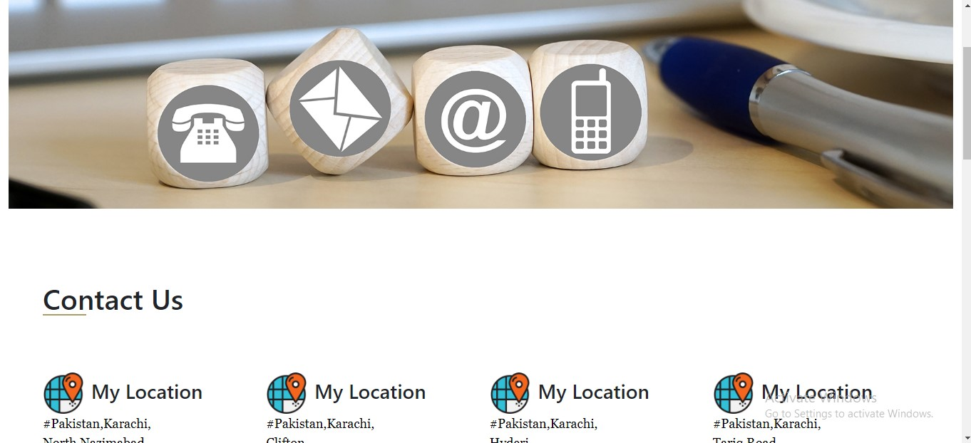

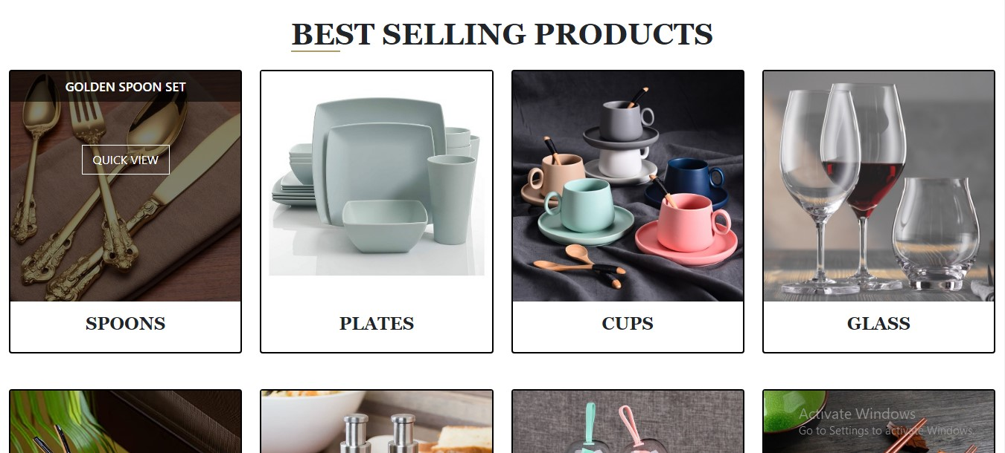

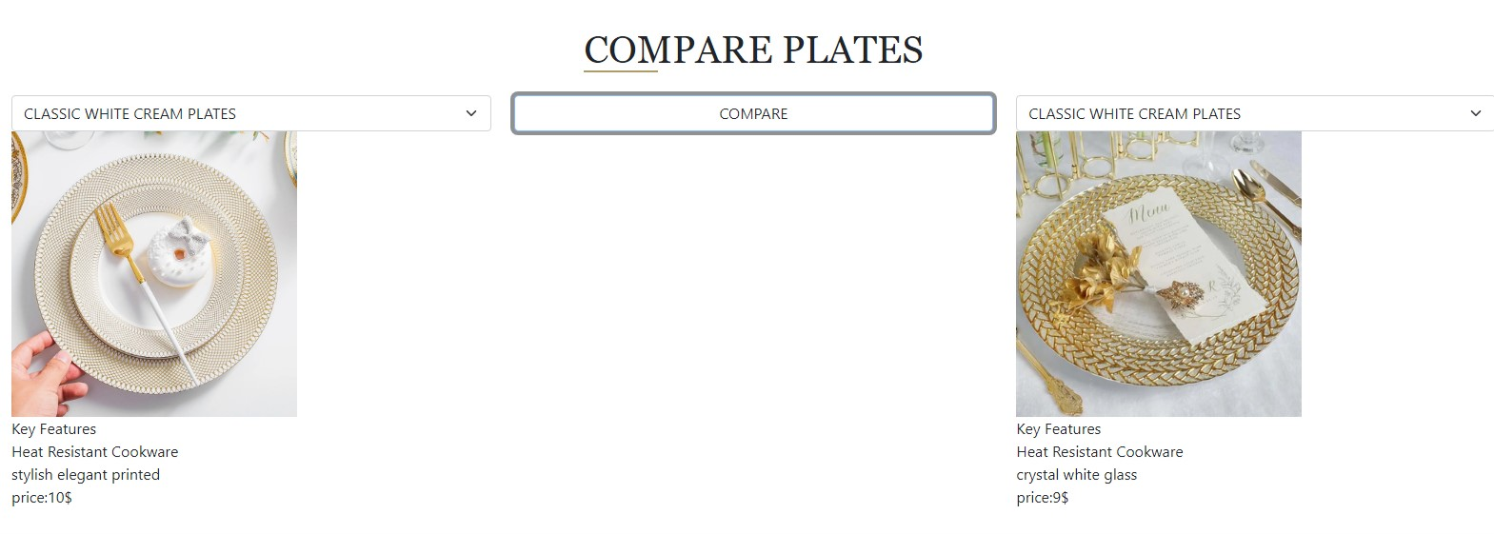

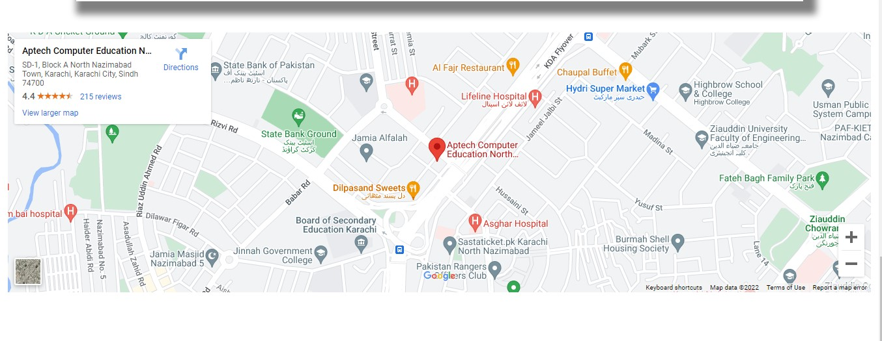

***TASK SHEET***

|  |  |  |  |  |  |
| --- | --- | --- | --- | --- | --- |
| **No.** | **Task** | **Actual Start Date** | **Actual Days** | **Team Mate Name** | **Status** |
| 1. | Case Study | 3 MARCH 2022 | 2 | MAHNOOR  NEHA  HASHIR AHMED | Completed |
| 2. | UI Designing | 5 MARCH 2022 | 9 | MAHNOOR  NEHA | Completed |
| 3. | SCENARIO Making | 10 MARCH 2022 | 8 | MAHNOOR  HASHIR | Completed |
| 4. | Material Searching | 13 MARCH 2022 | 3 | MAHNOOR | Completed |
| 5. | Database Connectivity | 20 MARCH 2022 | 6 | MAHNOOR | Completed |
| 6. | Documentation | 30 MARCH 2022 | 2 | MAHNOOR  NEHA | Completed |